**Personal Information**

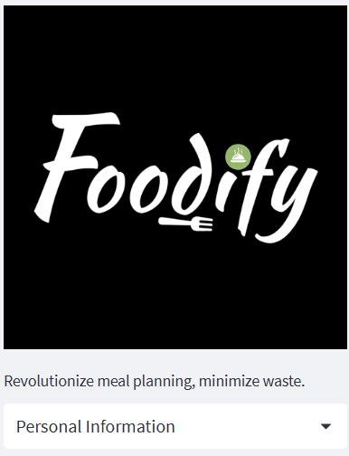

1)Introduction:

The Personal Information section of our food service application is designed to collect and store essential details about our users. This information helps us provide personalized experiences, seamless ordering, and efficient delivery services. We understand the importance of privacy and security, and we assure you that all personal data collected is handled in accordance with our privacy policy and applicable data protection laws.

2)Types of Personal Information Collected:

The Personal Information section may include, but is not limited to, the following types of data:

Full Name: We collect your full name to address you properly and ensure accurate communication.

Contact Information: This includes your phone number and email address. We need these details to keep you informed about your orders, delivery updates, and any relevant account-related information.

Delivery Address: To ensure prompt and accurate delivery of your food orders, we require your delivery address. You can save multiple addresses for your convenience.

Payment Information: We securely store your payment information, such as credit card details or preferred payment methods, to facilitate seamless transactions. Please note that sensitive payment information is encrypted and handled with utmost care.

Dietary Preferences: We provide options to capture your dietary preferences or restrictions, such as vegetarian, vegan, gluten-free, or allergies. This helps us tailor our food recommendations and menu offerings to better suit your needs.

Profile Picture: You have the option to upload a profile picture, which adds a personal touch to your account and helps us enhance your user experience.

3)Usage and Purpose of Personal Information:

We utilize the personal information collected in the following ways:

Order Processing: Your contact information, delivery address, and payment details are essential for processing your food orders accurately and ensuring smooth delivery.

Account Management: Personal information is used to create and maintain your user account, allowing you to manage orders, track delivery status, and access personalized features within the application.

Personalized Experiences: We may analyze your dietary preferences and ordering history to offer personalized recommendations, discounts, or promotions tailored to your tastes.

Communication: We use your contact information to send order confirmations, delivery updates, and promotional offers. You have the option to unsubscribe from marketing communications if desired.

Customer Support: Your personal information enables us to provide effective customer support, address inquiries, and resolve any issues related to your orders or account.

4)Data Security and Privacy:

We prioritize the security and privacy of your personal information. We implement industry-standard security measures to protect your data from unauthorized access, loss, or disclosure. Access to personal data is strictly limited to authorized personnel and is stored on secure servers. Please refer to our privacy policy for detailed information on data protection practices.

5)User Control and Rights:

You have control over your personal information and can update or modify it within the application's settings or profile section. You may also exercise your rights, such as data access, correction, or deletion, as permitted by applicable laws. For any concerns or queries regarding your personal information, please reach out to our support team.

Please review this documentation to understand how your personal information is collected, used, and protected within our food service application. By using our application, you consent to the collection and processing of your personal data as described in this documentation and our privacy policy.

Jaloliddin Sultonov 56296

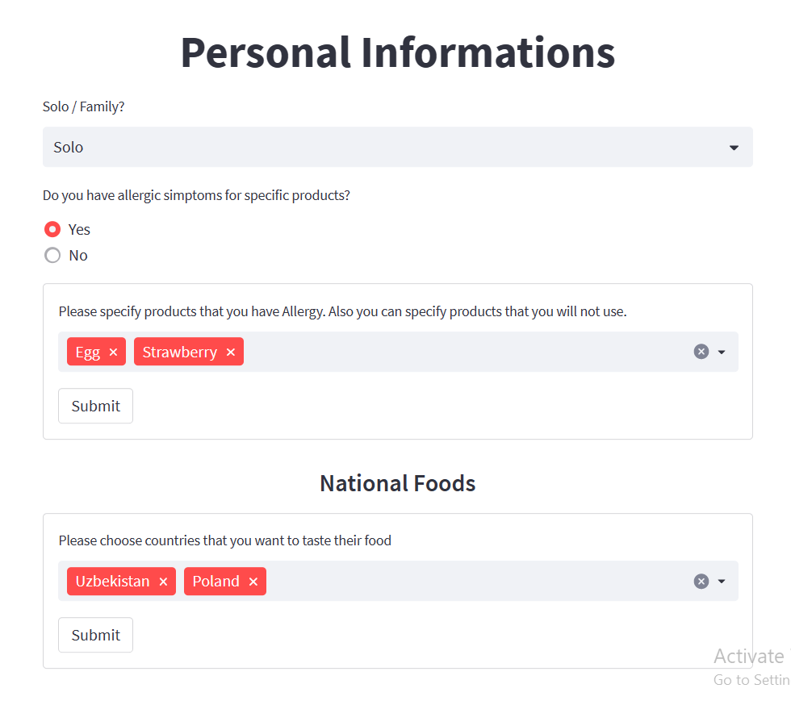

Within the displayed image, you will find additional buttons that allow you to specify your preferences for a more tailored experience. The first line offers the option to choose a meal plan suitable for either an individual or a family. This selection impacts the quantity of food and further customization options in subsequent steps.

Moving to the second line, users are prompted to indicate any allergies they may have. This information is crucial in ensuring their safety and well-being.

In the third line, users can select specific products, fruits, or vegetables that are known to trigger allergic reactions. Our program takes these choices into account and adjusts the displayed food options accordingly, excluding any items containing the selected allergens.

Finally, in the last line, users have the opportunity to explore various global cuisines. As shown in the example, the image showcases Polish and Uzbek cuisines, but there are likely many more options available. This feature enables users to discover and explore different culinary traditions from around the world.